******************The Blademaster******************

Grand Tuhon Leo T. Gaje

in Dallas/Ft. Worth September 20 and 21, 2003

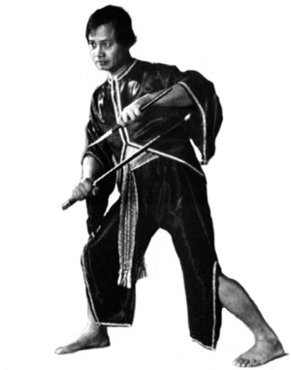

The Blademaster, Grand Tuhon Leo T. Gaje, Jr., Supreme Grandmaster of Pekiti-Tirsia Kali returns to North Texas to conduct advanced training seminars in combat Bladefighting. Discover the essence of close quarters combat and train with Tuhon Leo T. Gaje, the world’s leading authority on Edge-Impact weaponry and Filipino martial arts.

Tuhon Gaje has trained generations of world-class martial artists from all styles. Witness his legendary teaching skills and discover how he trains each individual to become an effective fighter and champion.

Pekiti-Tirsia is an attack system of combat proven strategy, tactics and techniques executed through the principle of offense, counter-offense, and recounter-offense. Seminar instruction will provide students with clear and concise knowledge, understanding, and skills in combat bladefighting and its application with all edged/impact/empty-hands weapons.

Learn the keys to applying effective combat technique through the Pekiti-Tirsia system. A true, authentic family system of Filipino martial art, tested and proven through generations of combat and utilized now by the elite Philippine Marine Corps Force Recon in the war against Terrorism.

Training will focus on the combat drills and tactical application of the Pekiti-Tirsia system with all weapon categories including Pangamut/Empty-Hands/Dumog. Participants should bring training weapons, protective gear, water/sports drinks for hydration and be prepared to train. ***Mat shoes recommended.

Training Fee: $125.00 for both days, $75 for one day
Date: September 20 and 21 (Saturday and Sunday), 2003 Open to all styles.
Time: 10:00 AM - 5:00 PM
Location: Taekwondo USA
100 West Southlake Blvd. Suite 440
Southlake, Texas 76092
Information: Tim Waid (214)738-8817 twaid@comcast.net
Jim Buchanan (817)992-5791 jim@texasmartialarts.com

